Group Members:
- Ali Asghar (2059)
- Shahad Bangash (1980)
- Suleman Shah (1983)

Converted Relational Schema:
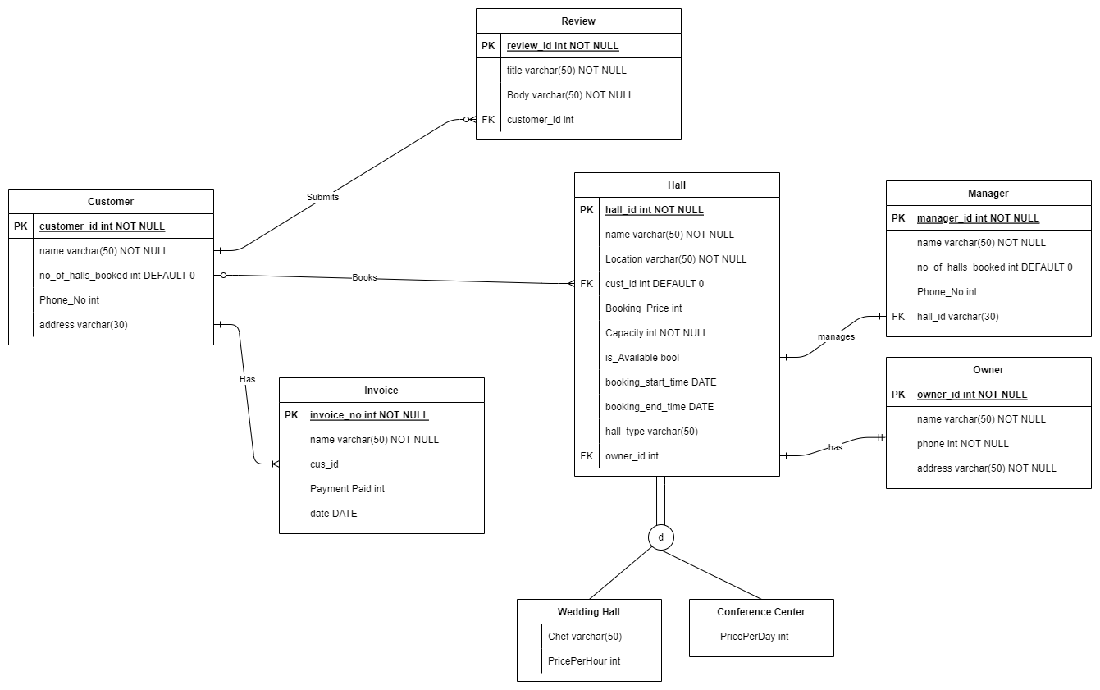
Unnormalized Relational Schema:
Figure 1-1, Unnormalized Relational Schema of Hall Booking System

Normalized Relational Schema:
First Normal Form (1NF)
The current schema is in 1NF as all attributes contain no multivalued attributes.

Second Normal Form (2NF)
All tables satisfy 2NF as all non-key attributes depend on the entire primary key.

Third Normal Form (3NF)
The hall_id in Manager Table should not be in the Manager table as it creates a transitive dependency (hall_id depends on manager_id, and attributes in the Hall table depend on hall_id). Instead, we create a separate Manages table.

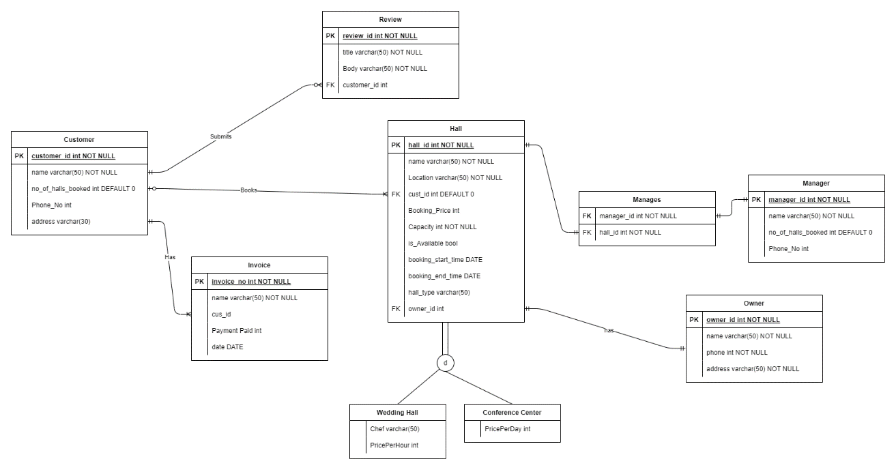
Normalized Relational Schema:
Figure 1-2, Normalized Relational Schema of Hall Booking System

